**TUGAS II**

**Data Warehouse dan Business Intelligence**

Nama : Alfaro BinotoTama Tambunan

NIM : 181402132

Kom : C

1. **Load the Data Cube**
2. Select the preloaded OLAP cube Microsoft Adventure Works (same cube used in tutorial) from the Demo list to create the pivot table.
3. Take some time exploring the data cube before beginning on the details of the assignment.

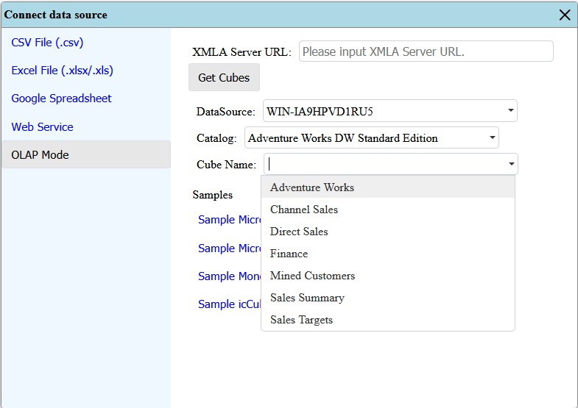

1. **Create the Pivot Table**

Create a customized pivot table that shows the following :

1. Expands the “Promotions” dimension in the Fields List.
2. Select “Promotions” field inside the “Promotions” dimensions tn the Rows area.
3. Expands the “Delivery Date” dimension in the Fields List.
4. Select “Delivery Date Month of Year” in the Columns area. If it appears in the Rows area, move it from the Rows to the Columns area.
5. Expands the Measures in the Fields List.
6. Select “Average Sales Amount” in the values area.
7. Take a screen snapshot and paste it into a document as the snapshot for part 2 of the Web Pivot Table assignment. The snapshot should show All Promotions and All Periods with complete expansion on the rows and columns with Average Sales Amount in the cells.
8. Keep the sheet open for the next part.

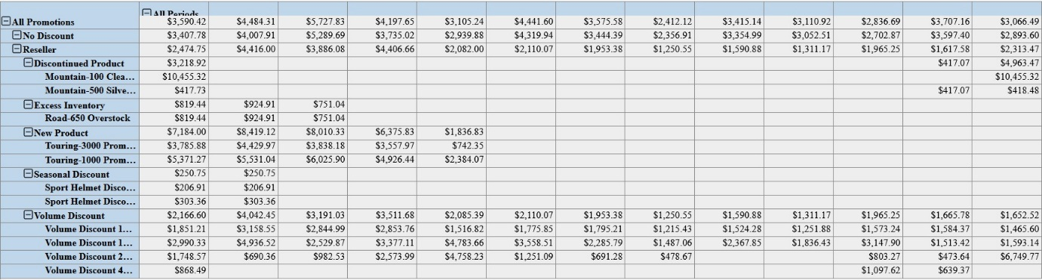

1. **Extend the Pivot Table**
2. Add “Source Currency” level (Do NOT include “ALL” level) from the Source Currency dimension to the Filters area.
3. Create a filter such that the pivot table displays value only for “ Canadian Dollar” and “USS Dollar”.
4. Take a screen snapshoot and paste it into a documents as the snapshot for part 3 of WebPivotTable assignment. The snapshot should show a complete expansion of All Periods and All Promotions with January Average Sales Amount in the cells.
5. Keep the sheet open for the next part.

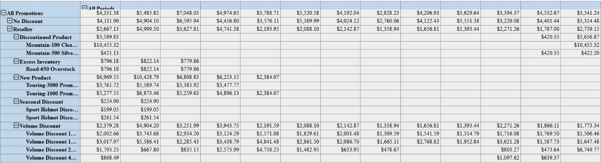

1. **Average the Pivot Table with Filter Changes and Rollups**
2. Modify the filter to show results only for the source Currency “EURO”.
3. Collapse all reseller promotions except for Excess Inventory. Show only the subcategories with in the Excess Inventory item.
4. Remove the pivot chart so that the sheet only displays the pivot table.
5. Take a screen snapshot and paste it into a documents as the snapshot for part 4 of the WebPivotTable assignment. The snapshot should show the Average Sales Amount for All Periods along with a subset of the expansion of All Promotions for Excess Inventory Promotions.

